

School of Computing, Creative Technology and Engineering

**Module: Fundamentals of Computer Science**

**Academic Year: 2020/21**

**Level 4: Term 1**

**Assignment Title: Academic Report**

**Date Due: 26th December 2020**

**Tutor: Associate Prof. Saroj Shakya**

**Student Name: Mr. Utkrista Acharya**

**Student ID: 77261056**

# Artificial Intelligence and Its Implication to Revolutionise the Education System of Developing CountriesContents

Introduction 3

## The Technicality: A Paradigm for Personalised Learning 5

## AIEd: Its Perks, Limitations and Developmental Prospects 7

*i. Automation of Administrative Tasks: Redefining the Role of Teachers*

*ii. Elimination of Learning Boundaries: Augmenting Knowledge*

*iii. Biometric Verification: The Developmental Analogy*

Conclusion 10

References 11

**Introduction**

The educational sector has always remained to be a deterministic factor in determining the progression of every nation. This might be the reason it has established itself as a degree of competition among nations driven to uphold their stature. In retrospect, the field that once required pen and paper for proper functionality is steadily being substituted by fabricated machines known as computers contemporarily. The age of Artificial Intelligence has caught up eventually, finding its application everywhere, and the field of ‘Education’ is not oblivious.

Fig.1 below depicts the developmental role of Education (UNESCO, 2020).

*Fig.1: Human Development Index Criteria*

A rough idea can be derived from Fig.2 below that although, the Asia Pacific market entails about 51% of the market share in the deployment of AI in education, developing countries like Nepal is rather inconspicuous.



*Fig.2: Artificial Intelligence Market Size* (Bhutani & Wandhwani, 2018)

The illustration might be missing out more of the countries spread across different continents. Nonetheless, many would be able to sustain by excelling in one field or the other. It sternly becomes an area of concern for the countries that uphold the repute of being underdeveloped due to which, their existence often gets obscured by the developed countries which lie within the same continent reigning supreme. The developing countries falling behind the developed ones in almost every field could benefit from the implementation of Artificial Intelligence in their ‘orthodox education system’. It would help them pick up the pace in the developmental race against time. The notion of Artificial Intelligence could work wonders in the field of education. In presence of AI, there could be a proper analytical breakdown of the level of understanding each student possesses. The dynamic analysis carried out would consequently depict what could be made from the lectures given. More importantly, the analytics would be in the form of a report accessible to the instructor. As a result, they would be able to provide feedback to the students pinpointing the areas that need improvement (Borge, 2016).

Artificial Intelligence as an entity has presented itself with endless possibilities. The feasibility to enhance the quality of education in developing countries would make it limitless. The purpose of this paper is to ideate the deployment of Artificial Intelligence in the field of education of developing countries, it’s modus operandi, delving into some of its technicality. Furthermore, it will also put forward some of its applications, constraints and viable countermeasures.

***The Technicality: A Paradigm for Personalised Learning***

Keeping all the technical jargon aside, the deployment of Artificial Intelligence would accord computer software to execute tasks that were once possible exclusively through human intelligence (Lu & Harris, 2018). An inference has been formulated whereby knowledge of the world can be broken down into so-called ‘models’. Artificial Intelligence in the field of education has been abbreviated as AIEd. The models governing it are as follows:

**i.The Pedagogical Model**

It deals with effective approaches to teaching under productive failure that would allow students to explore content whilst making mistakes before being handed out the correct answers.

**ii. The Domain Model**

It deals with the subject being learned involving feedbacks comprising of questions, hints, or haptics triggered by the intuition of students, designed for the sole purpose of enhancing their learning capabilities.

**iii. The Learner Model**

It deals with the student that is learning involving past achievements and prior difficulties encountered, considering the emotional state and their active engagement (Luckin, et al., 2016).

A model-based adaptive tutor is depicted in Fig.3 below. It embraces all the three models discussed above and presents itself as an algorithm. An algorithm that once processed through the system’s code is capable of processing the acquired knowledge in selecting the most appropriate content that is to be delivered. It keeps in check, the capabilities, and demands of the seeker. In concurrence to the delivery of the content, there is continual analysis of the learner’s interactions and achievements with constant feedback.

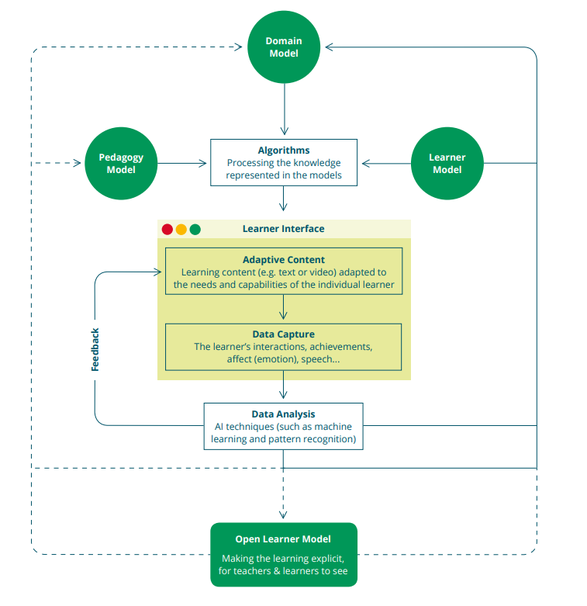

*Fig.3: AIEd System’s Typical Model-Based Adaptive Tutor* (Luckin, et al., 2016).

Furthermore, the analytic process is so deep that the student’s interactions are utilised to update the learner model, enhancing the accuracy and customising the experience. A major advantage of deploying the adaptive AIEd system in developing countries would be the availability of large amounts of data which could be cycled up and computed to dynamically revamp the pedagogy and domain models. The process in its entirety would avail in supplying new modes to account for more efficient, personalised, and contextualised assistance. Additionally, it would also be testing out and refining the process of teaching and learning entirely. Above all, the full-fledged implementation of the analytical algorithm would be able to narrow down the knowledge aspect for the seeker consequently providing strategic guidance based on their strength and weaknesses (Luckin, et al., 2016).

The students from the emerging nations even at their secondary level tend to lack the skill set of simple reading. For that reason, it has become a major developmental impediment. Moreover, AIEd with its quintessence personalized learning system could tackle down such problems with ease. The next section of this paper will look into the ways AIEd would surface out its quiddity, rejuvenating the education system of such nations.

## AIEd: Its Perks, Limitations and Developmental Prospects

Fig.4 below marks possible AI benefits in the field of education.

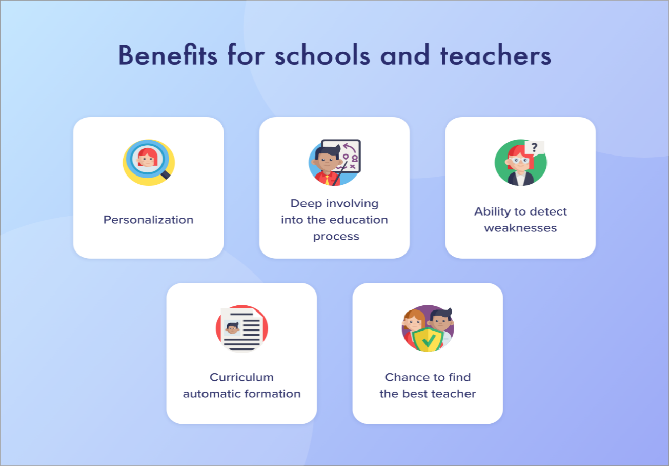

*Fig.4: AI Benefits for Schools and Teachers* (Kuprenko, 2020).

usmsystems (2020) writes that the potential of Artificial Intelligence has only enriched over time owing to the digital age the world is striding into. An instance would be the availability of online learning platforms like ‘Coursera’ that have concurrently evolved with AI. The degree of exposure has benefitted not just the learners but the service providers as well. For this reason, AI deployment in education has relatively induced marketing platforms. Holmes et.al (2019, p.10) mention that prominent companies like Amazon and Google have made multibillion-dollar investments subsidising AIEd companies like Knewton and Carnegic Learning. Furthermore, AIEd would guarantee unbiased learning opportunities in an omnipresent manner and greatly aid the ‘Sustainable Development Goal 4’ which aims to ensure the aforementioned. The developing nations could just endorse it by cherishing the essence (UNESCO Education Sector, 2019).

Some of its benefits are:

**i. Automation of Administrative Tasks: Redefining the Role of Teachers**

The grading system of developing countries have held them back and shifted the focus from the prime area of concern, which is providing a captivating learning experience. A significant amount of time gets wasted in grading papers, scheduling timetables etc., which could be mitigated with the implementation of AIEd. The technological innovations have allowed AI systems to grade in an objective question-based exam which happens to be the better judgment of the pupil’s understanding level. Furthermore, they will be able to refer to their performance in real-time proficiently with its expertise. The critical information generated would motivate them to try harder, in contrast to an instance when they got to see their final grades, too late for them to do anything. Some may argue, this could lead to the surrogation of teachers and would come at the cost of capitalising one field hampering the other. However, it will also benefit the teachers, markedly reducing workloads for them to improvise their teaching modality (Mittal, 2019). Even though AI programs could teach the students elementals, it is not an epitome in assisting their higher-order thinking. This would constantly require facilitation from the teachers themselves (TeachThought, 2018). The facilitation would help in eradicating AI biasing which at times could hurt the sentiment of learners (Kulkarni, 2019).

**ii. Elimination of Learning Boundaries: Augmenting Knowledge**

The underdeveloped countries have been stuck with the age-old morale of assigning different degrees depending upon the calibre of the students, consequently restricting them from seeking knowledge outside their fields. Artificial Intelligence would inaugurate a learning system without demarcations. Furthermore, it will enhance the field of education adding up to the reformatory phase. A fault that could be encountered nevertheless would be shifting of focus from the learner’s field of major. However, this could be eradicated by establishing a priority-based system accounting for content delivery based on their interests and relative majors. Additionally, this would also provide an insight into enhancing a particular course, analysing the choices made by the learner.

**iii. Biometrical Verification: The Developmental Analogy**

The underdeveloped countries associating with AIEd could generate biometric attendance records through a tracking mechanism which would be put into utilisation as a base of comparison of education in different states within the

country. As a result, this would be an indicator pin-pointing the areas that require immediate attention and would consequently assist the concerned authorities in making educational policies accordingly. Likewise, it will also be measuring out the quality of education provided by different schools within the country by establishing a sense of competition among states, contributing to its all-round development (Dialani, 2020).

Fig.5 below proposes a model for AIEd deployment in augmenting developmental prospects for the developing countries (Luckin, et al., 2016).





**Artificial Intelligence**



Students

Data Filtration

Data Manipulation

Database







Analysis

Strategise

Teachers

Identification

Visualisation





Augmented Prospects

Developmental Pace

*Fig.5: Proposed AIEd Deployment Model*

# Conclusion

The 21st century has undoubtedly become a golden age for the technological advancements that have taken the world by storm with its exponential growth. Artificial Intelligence is no stranger due to the tangency of its deployment in many of the sectors. The instigation of AI in the field of education has bestowed itself as a benchmark for development. It has also surfaced itself out with endless possibilities looking to redefine the standard of education in developing countries. The integration of personalised learning in the education system of such countries would provide them with the opportunity to ameliorate their biased rudimentary education system. AIEd would also tailor the experience based on the needs and abilities of students regardless of disparities, depriving no one of their right to education. The provision of automating administrative functions and the establishment of a boundaryless education system would significantly add up to the reformative process. Lastly, biometric verification would serve as a comparison basis, initializing a sense of competition among states that would ultimately lead to the all-round development of the system. All things considered, the amalgamation of Artificial Intelligence in the field of education of developing countries would revolutionise the system with its valuable prospects.

# References

Bhutani, A. & Wandhwani, P., 2018. *Artificial Intelligence (AI) in Education Market Size.* [Online]   
Available at: https://www.gminsights.com/industry-analysis/artificial-intelligence-ai-in-education-market  
[Accessed 14 December 2020].

Borge, N., 2016. White paper - Artificial Intelligence to Improve Education / Learning Challenges. *International Journal Of Advanced Engineering & Innovative Technology (IJAEIT),* pp. 10-13.

Dialani, P., 2020. *How Artificial Intelligence is Empowering The Education Sector?.* [Online]   
Available at: https://www.analyticsinsight.net/artificial-intelligence-empowering-education-sector/  
[Accessed 14 December 2020].

Holmes, W., Bialik, M. & Fadel , C., 2019. Artificial Intelligence In Education Promises and Implications for Teaching and Learning. In: *Artificial Intelligence In Education Promises and Implications for Teaching and Learning.* Boston: Center For Curriculum Redesign, p. 10.

Kulkarni, A., 2019. *AI in Education: Where is It Now and What is the Future?.* [Online]   
Available at: https://www.lexalytics.com/lexablog/ai-in-education-present-future-ethics  
[Accessed 14 December 2020].

Kuprenko, V., 2020. *Artificial Intelligence in Education: Benefits, Challenges, and Use Cases.* [Online]   
Available at: https://medium.com/towards-artificial-intelligence/artificial-intelligence-in-education-benefits-challenges-and-use-cases-db52d8921f7a  
[Accessed 14 December 2020].

Luckin, R., Holmes, W., Griffiths, M. & Forcier, L. B., 2016. Intelligence Unleashed: An argument for AI in Education. In: *Intelligence Unleashed: An argument for AI in Education.* London: Open Ideas At Pearson, pp. 20-21.

Lu, J. J. & Harris, L. A., 2018. Artificial Intelligence (AI) and Education. *In Focus,* August.p. 1.

Mittal, V., 2019. *How AI will be a game changer for Indian education system.* [Online]   
Available at: https://vartulmittalspeaker.medium.com/how-ai-will-be-a-game-changer-for-indian-education-system-befa9bc6b7bd  
[Accessed 13 December 2020].

TeachThought, 2018. *10 Roles For Artificial Intelligence In Education.* [Online]   
Available at: https://www.teachthought.com/the-future-of-learning/10-roles-for-artificial-intelligence-in-education/  
[Accessed 15 December 2020].

UNESCO Education Sector, 2019. Artificial Intelligence In Education: Challenges and Opportunities for Sustainable Development. *Working Papers on Education Policy,* p. 12.

UNESCO, 2020. *Human Development Index (HDI).* [Online]   
Available at: http://hdr.undp.org/en/content/human-development-index-hdi  
[Accessed 13 December 2020].

usmsystems, 2020. *Is Artificial Intelligence A Game Changer In Education Industry?.* [Online]   
Available at: https://www.usmsystems.com/is-artificial-intelligence-a-game-changer-in-education-industry/  
[Accessed 14 December 2020].